Romania, a land of choice

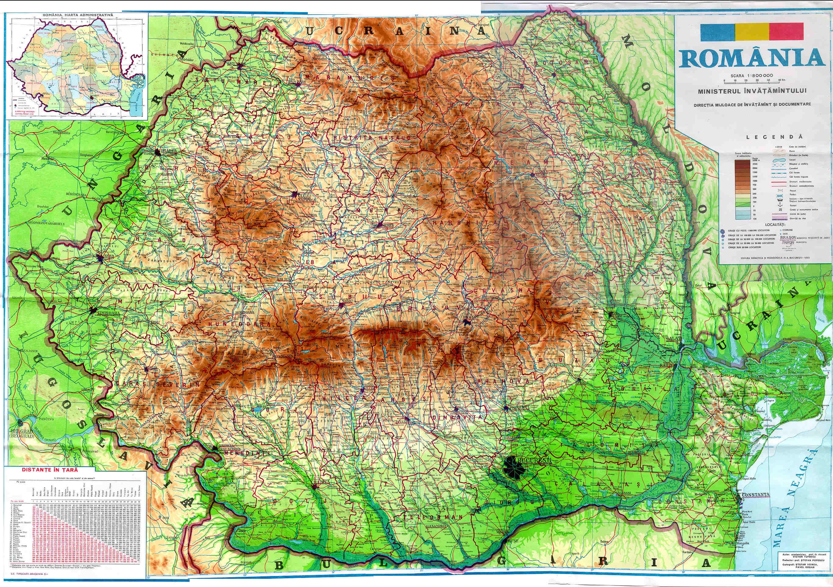
With a surface area of 238,391 km², Romania is the largest country in southeastern Europe and the twelfth-largest in Europe. Three elements have decisively marked the destiny of this area: the Carpathian Mountains, the Lower Danube and the opening to the Black Sea. With their arched form, the Carpathians determined the position of three big historical regions - the intra-Carpathian space, opening to Central Europe, the area east of the mountains, opening to the North Pontic steppes and the one south of the mountains, facing the Balkan Peninsula. The Danube (Europe's second longest river), which separates the Carpathian area from the Balkan world, has always provided a connection between Central Europe and the Black Sea, and has opened a gate towards the Mediterranean and the eastern world. Therefore, Romania equally belongs with the Danubian and the Black Sea states, its territory constituting a bridge between Central and Southeastern Europe and the Near East.

The Danube, meaning "to flow, run" is the longest river in the European Union and Europe's second longest river after the Volga. It originates in the Black Forest in Germany and flows eastwards for a distance of some 2850 km (1771 miles), passing through ten countries: Germany (7.5%), Austria (10.3%), Slovakia (5.8%), Hungary (11.7%), Croatia (4.5%), Serbia (10.3%), Romania (28.9%), Bulgaria (5.2%), Moldova (1.7%), and Ukraine (3.8%), 4 Central and Eastern European capitals, before emptying into the Black Sea via the Danube Delta in Romania and Ukraine. It is known to history as one of the long-standing frontiers of the Roman Empire. Just beyond the Romanian city of Orsova, there is a gorge that contains a hydroelectric dam, with two power stations, Iron Gate I Hydro Power Plant and Iron Gate II Hydro Power Plant.

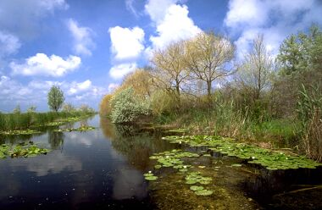
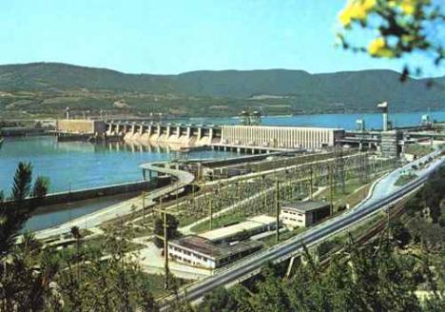
The Danube flows into the Black Sea within Romania's territory forming the Danube Delta, the second largest and the best preserved delta in Europe, and a biosphere reserve and a biodiversity World Heritage Site. The Danube Delta - is probably the most secluded and least populated region of modern Romania. The three main towns here are Tulcea, Sulina and Sfantu Gheorghe. Fishing and wildlife watching excursions to the surrounding lakes and forests attract more and more visitors.The Danube Delta is the second largest delta in Europe, after the Volga Delta, and the best preserved on the continent. It is a peaceful natural habitat for thousands of rare birds and animals. Designated a UNESCO World Heritage Site and named "Landscape of the Year 2007-9", the region is also a designated Ramsar zone. This is the inter-governmental agreement signed in 1971 at Ramsar, Iran, that established guidelines for conservation and protection of wetlands and their natural resources.

The delta is either home to, or visited by, thousands of migrating birds throughout the year. Pelicans, both Dalmatian and white, great egret and little egret, pigmy cormorant, red-necked goose and night heron are just a few of the species, many of which are endangered, that can be seen on the delta. The wildlife of the Danube Delta includes wild animals and fish such as otter, European mink, muskrat, wild boar, wild cat, raccoon dog, fox and stoat. The delta also shelters European tree frogs, European pond terrapin, meadow viper, dice snake, edible frog, grasshopper, seven spot ladybird, earwigs, banded demoiselle, and of course, pike, carp, sterlet, catfish, bream and sturgeon, famous for its black caviar.
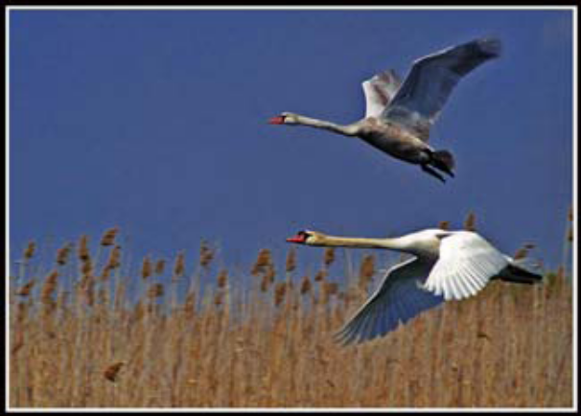
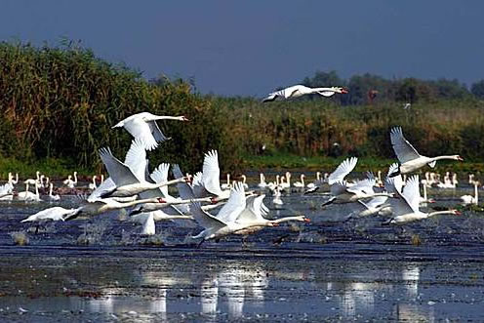
Other important rivers are the Siret, running north-south through Moldavia, the Olt, running from the oriental Carpathian Mountains to Oltenia, and the Mureş, running through Transylvania from East to West Romania's terrain is distributed roughly equally between mountainous, hilly and lowland territories.
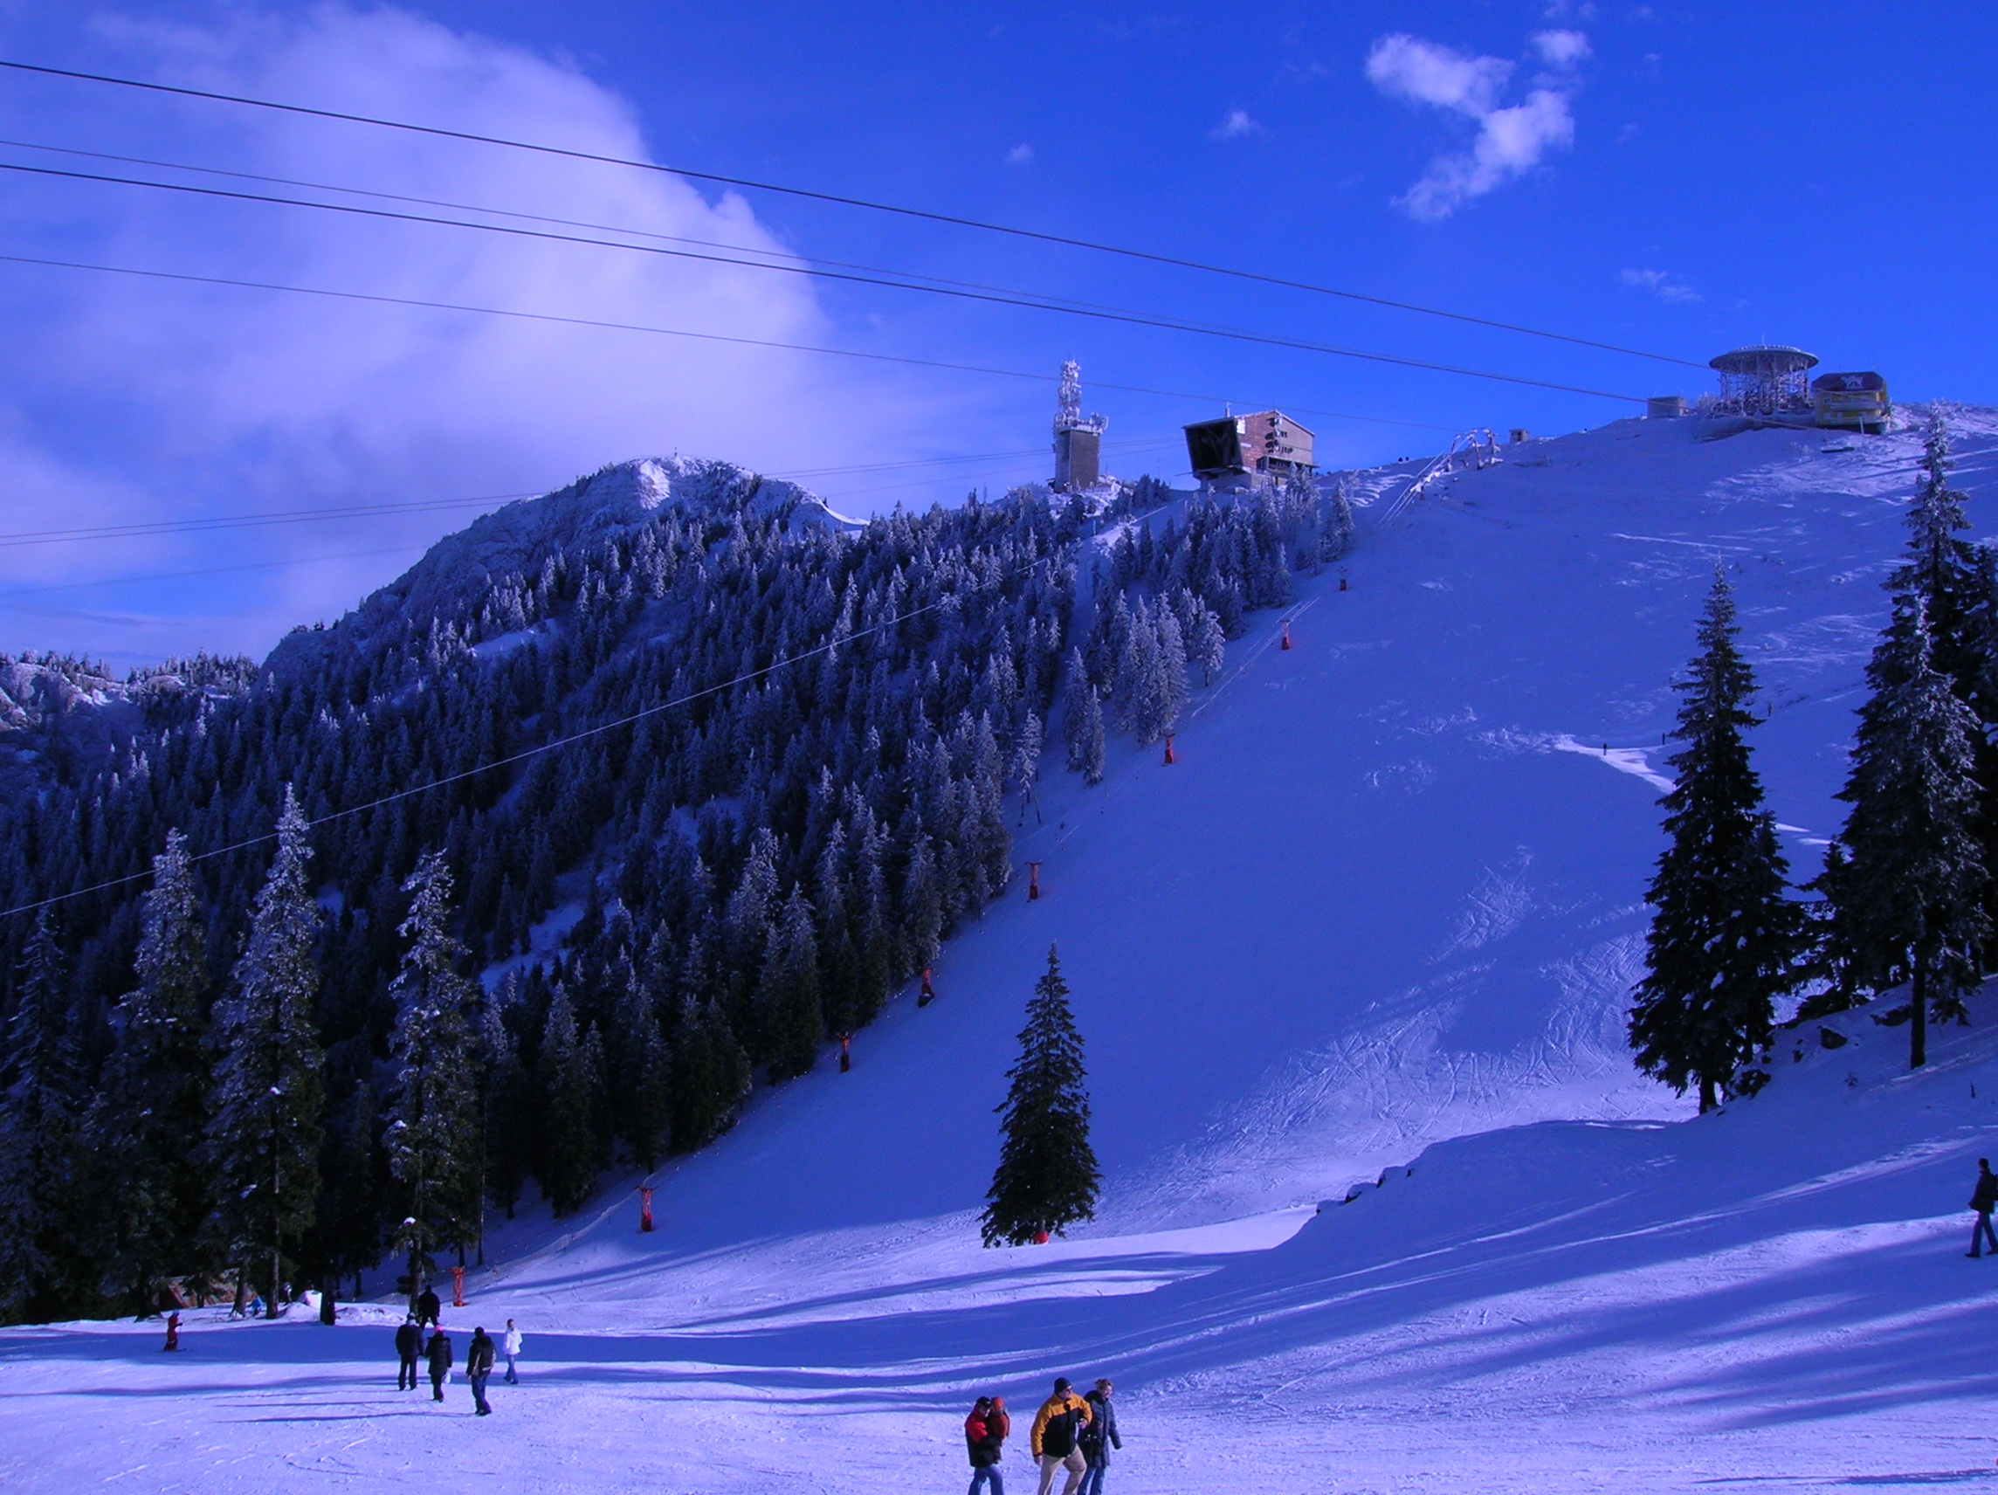
The Carpathian Mountains dominate the center of Romania, with fourteen of its mountain ranges reaching above the altitude of 2,000 meters. In south-central Romania, the Carpathians sweeten into hills, towards the Bărăgan Plains. Romanian mountains are pretty well known for their ski resorts. But few people realize that from spring right through to autumn the Carpathians offer hundreds of miles of idyllically unspoiled alpine meadows, forests, lakes, rivers and secluded valleys, challenging mountain peaks. The first two highest peaks are located in the Fagaras Mountains (2544m and 2535m). Other high mountains are Parâng, Bucegi and Retezat, the last one having a huge national park (380 km²), founded in 1935, with altitudes vary between 794m at the park entry on Râu Mare valley and 2509m at Peleaga Peak.
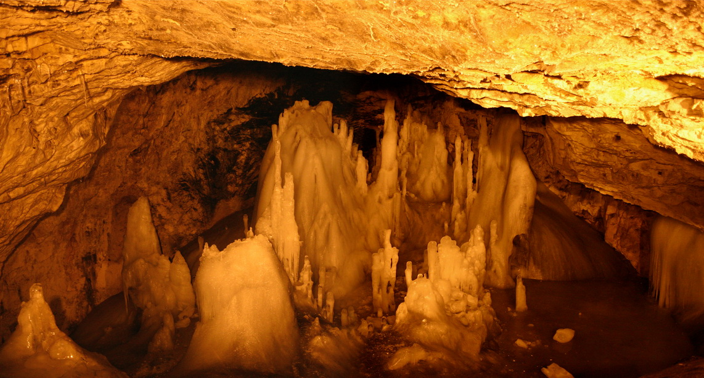
Scărişoara Cave is one of the biggest ice caves in the Romanian part of Carpathians, more specifically in the Apuseni Mountains. The cave is located at an altitude of 1165 metres above sea level. The cave is 105 m deep and 720 m long, the entrance shaft (50 m in diameter and 48 m in depth) giving access through metal stairs to a large chamber, (108 m long, 78 m wide) - The Big Hall.
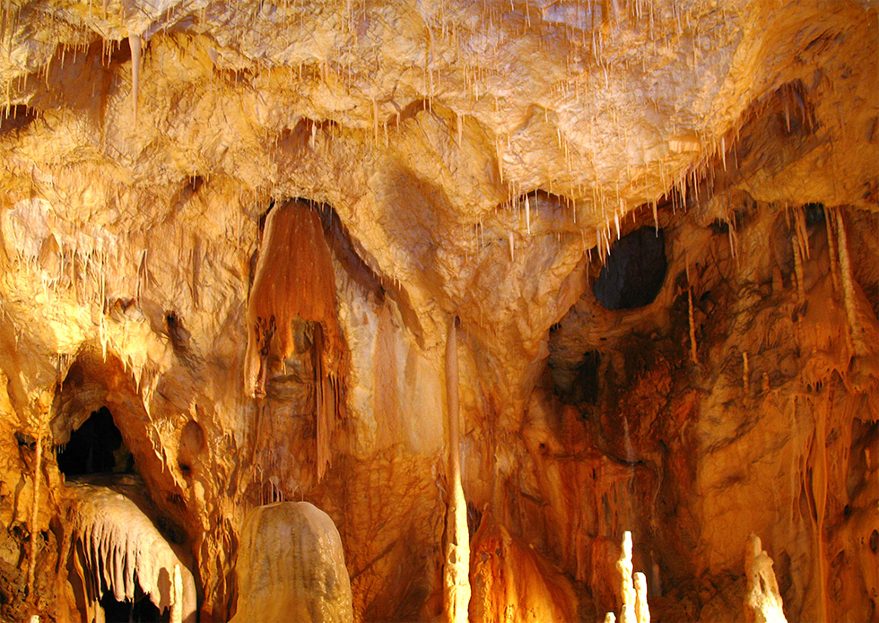
Known as one of the spectacular touristic objectives of Apuseni Mountains, Bears Cave lies in the vicinity of the location called Chiscau, in Pietroasa Commune, Bihor District, at an altitude of 482 meters. The name of the cave is due to the numerous bear fossils, which were found there, so therefore it represented a favorable place for shelter for the animals that used to live there 15000 years ago. Owing to the falling of a huge rock, the mouth of the cave was blocked and more than 140 bears were trapped inside. Being hungry, the bears attacked one another until they all died.

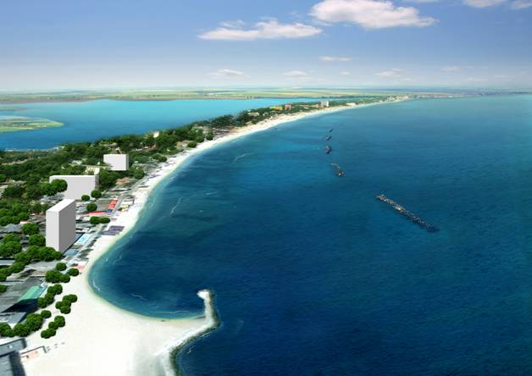
Practically all of the Romanian Black Sea shore is a chain of resorts. The beach is wide and public, with fine golden sand and calm water. Each summer thousands of Romanians from other areas visit the riviera along with thousands of other nationalities. But still the Romanians themselves are in majority when it comes to tourism to this part of the world. The average number of foreign visitors over the last year has been more than 54000 each summer while the natives number almost 2 million.
Mamaia, the oldest resort, located near the city of Constanta offers the largest beach. Mamaia has numerous hotels ranging from 4 star accommodations to camping and a wide sampler of excellent restaurants. Along the coast you can find all the sea side resorts: Eforie Nord, build by the Romanian kings in the `20s, Eforie Sud rather a city transformed into a resort, Costinesti preferred by young people, Olimp, Neptun - the most expensive of all the Romanian resorts, and well deserves the price, Jupiter, Cap Aurora, the newest and the most elegant of all the resorts, Venus, a youth-oriented resort, Saturn has probably the most inexpensive hotels, although the beach here is one of the nicest, Doi Mai, more like a village than a resort and Vama Veche even more “naturist".
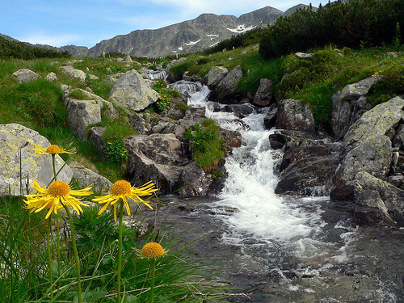
Romania's geographical diversity has led to an accompanying diversity of flora and fauna. A high percentage (47% of the land area) of the country is covered with natural and semi-natural ecosystems. Since almost half of all forests in Romania (13% of the country) have been managed for watershed conservation rather than production, Romania has one of the largest areas of undisturbed forest in Europe. The significance of the biodiversity of the Danube Delta has been internationally recognised. It was declared a Biosphere Reserve in September 1990, a Ramsar site in May 1991, and over 50% of its area was placed on the World Heritage List in December 1991. Within its boundaries is one of the most extensive reed bed systems in the world.

Made by: Aramă Adrian, X C, Hanu Anca Ioana, XI F, Ispas Mihai Cosmin, X A, Gheorghiţă Greta, XI F

