A short history of our school

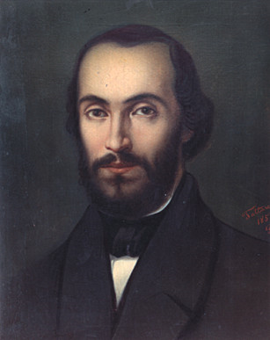
The Highschool “Nicolae Balcescu” is established at 21 January 1863 by order of “Minister of Cults and Public Instruction”, as primary school, and inaugurated at 6 December 1863. The initiative to name the school after the great Romanian revolutionist Nicolae Bălcescu belongs to the school principal in 1886, Mr. Atanasie Popescu. The school became National College “Nicolae Balcescu” short after 1990, and it remained that way until today.
Nicolae Balcescu was a founding member of the secret society “Justice and Brotherhood” (1843); he was an active participant to the 1848 revolution and became a member of the provisional government set up in Bucharest that year. Hero and martyr, he sacrificed his health studying historical documents. He wrote many works (literature, historiography, sociology and political economy), the most important being “Romanians under the rule of Michael the Brave”, where he discuss the ideal of national unity in an era when the Romanian people where divided into several states.
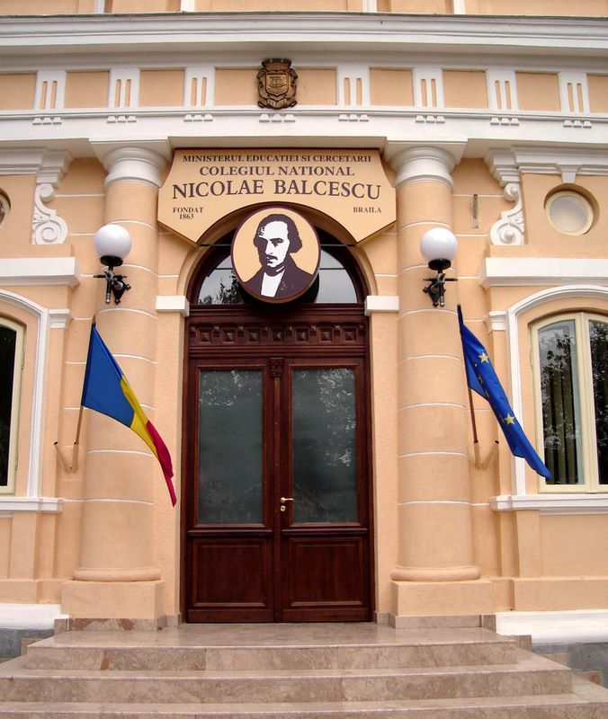
Nowadays, the bust and the picture of Balcescu stay right at the entrance of the College.
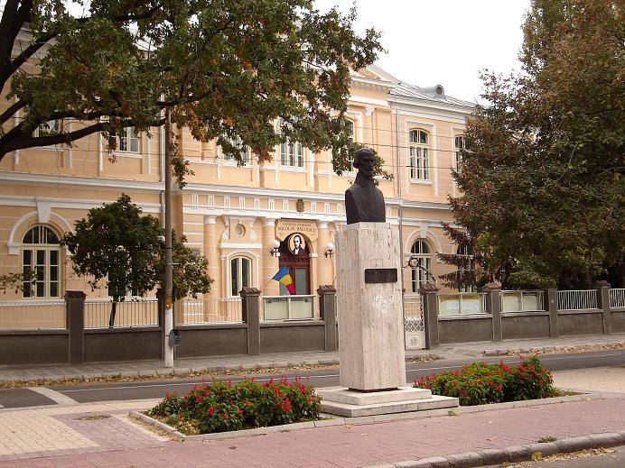

During the time, our school pass over many changes, such as:
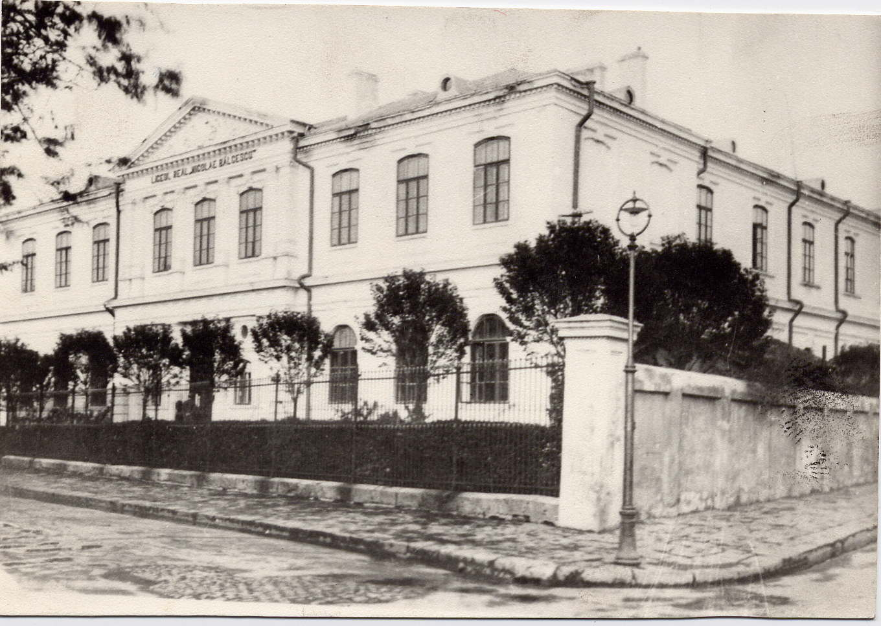
- In 1867 it has been transformed in gymnasium, becoming then in 1871 a trade school;
1985
- At 1 September 1888 it became the first Real High school of the Kingdom of Romania;
- At 1 September 1888 it became the first Real High school of the Kingdom of Romania;
- At 29 October 1945 the high school was renovated;
- Between 1954-1955 the school was named “The Middle School of Boys”;
1995
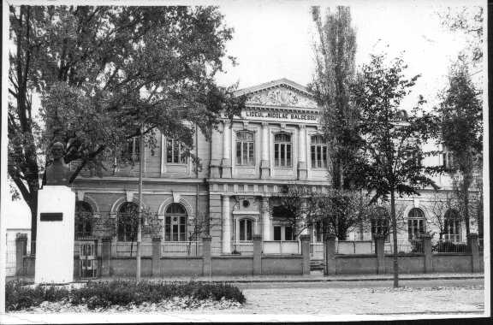
- Later, between 1956-1957, because of the reunion of boys and girls in the school, it became “The Middle School Number 2”;
Scientists that have graduated here: Ana Aslan, Victor Valcovici, Nicu Boboc, Mina Minovici and writers, Camil Baltazar, Panait Cerna, Mihail Sebastian.

2009
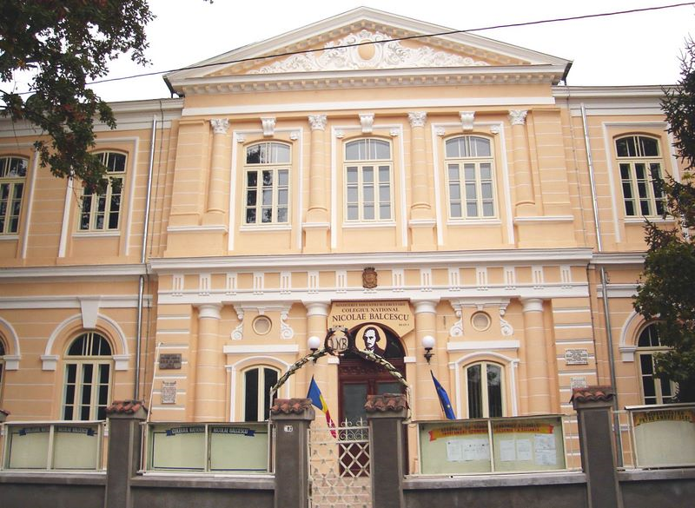

Made by: Epifanov Denisse, X A

